
e-Mobile Today

Overview
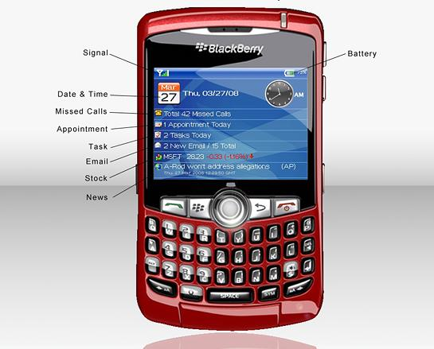

Installation
To install e-Mobile Today, please make sure Blackberry Desktop Manager is installed on your desktop computer.

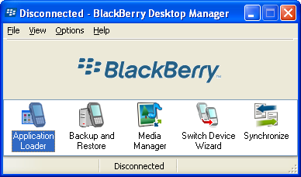

Unzip the installation zip file to a folder on your computer. Connect your Blackberry device to your computer using a data cable.

Launch Blackberry Desktop Manager, and double click “Application Loader”.

Follow the wizard and you will see a list of software on your Blackberry. Click “Add” button and browse to the directory where you unzipped the installation file.

Highlight e-MobileToday.alx file and select Open and click Next. “e-Mobile Today” will be installed on your Blackberry. Connect your device with computer using a data cable.

System Requirement
- Internet enabled Blackbery Pearl, Curve and 8800 series devices.
- OS 4.2.0 and up.
- For 87xx devices, device must have OS 4.2 and up installed.

Operational Issue/Tips
1. Receive "no additional applications designed for your device were found" error during installation,
The problem is that BlackBerry desktop manager you have is not updated. You can download the latest from:
http://na.blackberry.com/eng/support/downloads/download_sites.jsp
If you wish to install over the air, please send us your purchase info and let us know the type of device you have, we will prepare a wireless download for you. We can be reached at: support@e-mobilesoft.com
2. Cannot select “Weather”, “News”, “Stock” from the setting page
Those plug-ins are enabled via e-Mobile Today Weather, e-Mobile Today News and e-Mobile Today Stock which are sold separately.
3. Receive “Network Error” under News, Stocks or Weather.
Device internet connection might be interrupted due to various reasons, this will result in communication error when news, stocks or weather plug-ins are retrieving data. Please select “Refresh” menu and update.
4. Still receiving “Network Error” under News, Stocks or Weather even after Refresh.
Please check device APN settings. Select "Option", then "Advanced Options", and open "TCP", check your APN settings. It might be blank.
To configure if your carrier is T-Mobile or Cingular:
For T-Mobile users, enter the following:
APN: wap.voicestream.com
Username: < leave blank>
Password: <leave blank>
For Cingular users, enter the following:
APN: wap.cingular
Username: WAP@CINGULARGPRS.COM
Password: CINGULAR1
(Note: All of the above values are case sensitive.)
Return to the main screen and select Options. Next, select Security Options, then Firewall. Click the thumbwheel and select Reset Settings. Return to the main screen
To configure if your carrier is NOT T-Mobile or Cingular, You can find correct settings here:
Carrier specific APN/TCP settings
http://www.blackberryfaq.com/index.php/Carrier_specific_APN/TCP_settings
Other carrier's settings
http://www.blackberryforums.com/blackberry-network/2185-blackberry-internet-msn-chat-web-telnet-tcpip-no-bes.html
http://www.pinstack.com/carrier_settings_apn_gateway.html
or get this information from your carrier.
5. 87xx devices menu and tab navigation
For 8700, press the "enter" key will display menu. Press the "$" or Alt $ will navigate among tabs.
6. Expand/Collapse plug-in
Select each plug-in (appointment, task, email etc.) and press the trackball to expand for details.
Press the space bar to toggle between expand/collapse state.
6. Change default settings, i.e. Clock display, stock symbols, news content etc.
From application screen, select “Setting” menu. This will display the settings page. Use trackball to select the page you want.
7. View appointments and tasks for upcoming days.
Expand appointment or task, move trackball left/right to select upcoming days to view appointment/tasks under those days.

8. Hide completed tasks.
Select “Setting” menu and use trackball to select “Task” tab and check “Display only incomplete tasks”.

More products
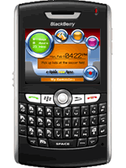  e-Mobile Voice Memo: Task management, Alerts and more | 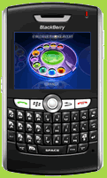  e-Mobile Phone Alert |   PocketStreamer: Live radio, music on the GO!

Please visit: http://www.e-mobilesoft.com

Contact us
If you have any questions or comments about the products, please feel free to contact us at: support@e-mobilesoft.com. Company website: http://www.e-mobilesoft.com

