
e-Mobile Color Pearl

Overview
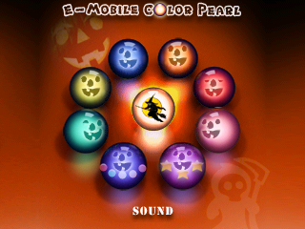

• Set trackball color or LED color (8800 series)
• Create your own color.

- Play Halloween sound effects.
Installation
To install e-Mobile Color Pearl, please make sure Blackberry Desktop Manager is installed on your desktop computer.

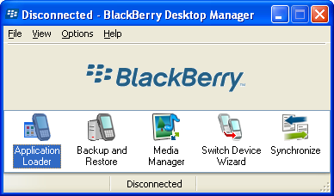

Unzip the installation zip file to a folder on your computer. Connect your Blackberry device to your computer using a data cable.

Launch Blackberry Desktop Manager, and double click “Application Loader”.

Follow the wizard and you will see a list of software on your Blackberry. Click “Add” button and browse to the directory where you unzipped the installation file.

Highlight e-MobileColorPearl.alx file and select Open and click Next. “e-Mobile Color Pearl” will be installed on your Blackberry. Connect your device with computer using a data cable.

System Requirement
- Blackbery Pearl and 8800, 8300 series devices.
- OS 4.2.0 and up.

Operational Help
How do I set my BlackBerry trackball color?
Open “e-Mobile Color Pearl” and select the color of your choice, press the trackball to select the color.
Why isn’t my BlackBerry trackball not showing color, instead the LED status light is?
For 8800 series devices, the trackball is not multicolor by design. Only LED light will work.
I receive “No additional applications were found.” error during installation, what should I do?
There are 3 possible causes of this problem:
1. e-Mobile Color Pearl is already installed, and you need to delete it. To do this, select e-Mobile Color Pearl from the list of applications in the Application Loader, then click the Delete button. Then click Next. Now you should be able to add the ALX file on the next time around.
2. You need to update your BlackBerry Desktop Manager software:
http://www.blackberry.net/products/software/desktop/index.shtml
3. You need to update the BlackBerry handheld software:
Cingular Software Downloads at:
https://www.blackberry.com/Downloads/entry.do?code=577BCC914F9E55D5E4E4F82F9F00E7D4
Nextel Software Downloads
https://www.blackberry.com/Downloads/entry.do?code=C8ED21DB4F678F3B13B9D5EE16489088
T-Mobile Software Downloads
http://www.t-mobile.com/bbupgrade/

More products
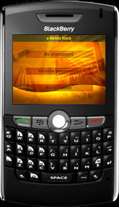  e-Mobile Stocks | 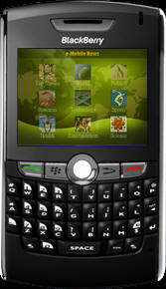  e-Mobile News | 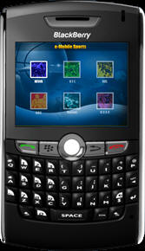  e-Mobile Sports

Contact us
If you have any questions or comments about the products, please feel free to contact us at: support@e-mobilesoft.com

